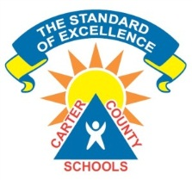
Team Members:
______________________________________________________________________________________________________________________________________________________
Strategies That Work
Literature Circles

Connector - Your job is to connect what you are reading with what you are studying or with your current classroom practices. You can make connections to books you’ve already read. The connections should be meaningful to you and those in your group.

Questions to Ponder
What connections can you make to your own classroom practices?
 What other places or people could you compare these ideas?
 What is the most interesting or important connection that comes to mind?
 How can you apply what you have learned in these chapters to you current practices?
Thoughts about this chapter

Chapter ____ Strategy Assignment

