GOOGLE DOCS
This information sheet covers how to:
1. Use the Explore Feature/Omnibox in Docs
2. Sharing Docs
3. Adding Comments to Docs with a URL
4. Highlighting Text in Docs

What is the Explore feature and where is the omnibox?
Explore is a feature that can be found in the omnibox in Docs The omnibox will be on the right hand side of your doc at the bottom, and looks like a square with a plus sign in it. Explore makes researching and writing reports on the go a whole lot 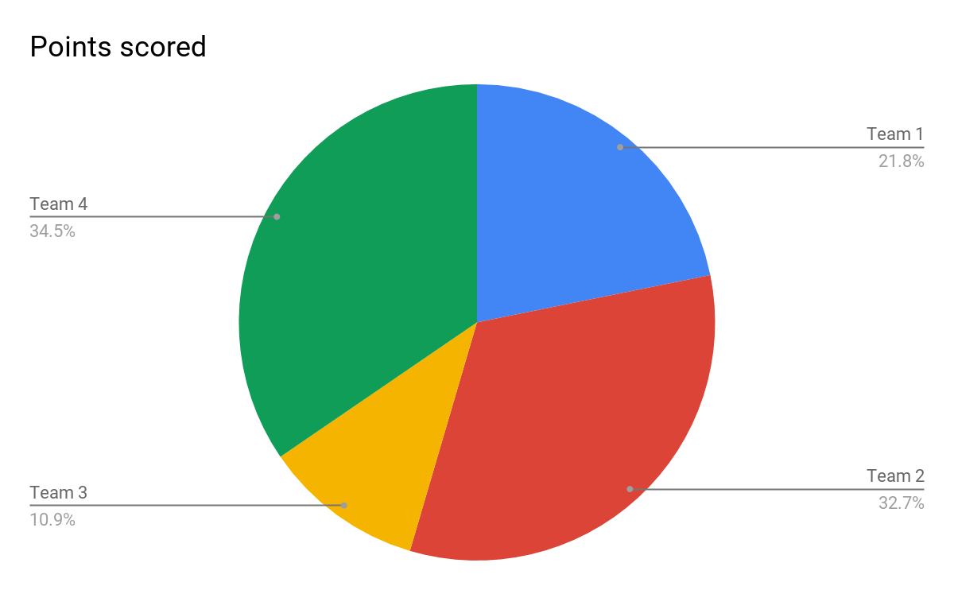easier. Whether you’re writing about mobile retail trends or planning your next team offsite, you’ll get instant suggestions based on the content in your document.
Share documents
Share a file you own or can edit:
- Open the file you want to share.
- Click Share.
- Enter the email addresses or Google Groups you want to share with.
- Choose what kind of access you want to grant people:
  - Can edit—Collaborators can add and edit content as well as add comments.
  - Can comment—Collaborators can add comments, but not edit content.
  - Can view—People can view the file, but not edit or add comments.
- Click Send.
Everyone you shared the document with receives an email with a link to the document.
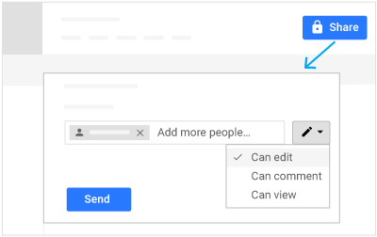

Add comments and replies
If you can’t collaborate in real time, you can leave feedback and questions on the side of the document for team members to look at when they open the file.
- Select a section of text.
- On the toolbar, click Add comment .
- Add your notes and click Comment.
If a comment is important for a specific collaborator to see, enter + followed by their address. They’ll get an email with your comment, along with a link to the document. They can then reply to your comments to answer questions or start a discussion.
When you’re done with a comment, click Resolve. To add a URL, control C and Control V (cut and paste the URL inside the comment box.

How to Highlight T``ext in Docs
Double-clicking a word highlights the word and triple-clicking a word highlights the full line or paragraph of text. To highlight with your keyboard, move to the starting location with the arrow keys, hold down the Shift key, and while holding Shift, press the arrow key in the direction you want to highlight.
To highlight text with a color, highlight as above, go to font (capital letter A) drop down menu, choose “highlight”, choose a color.

