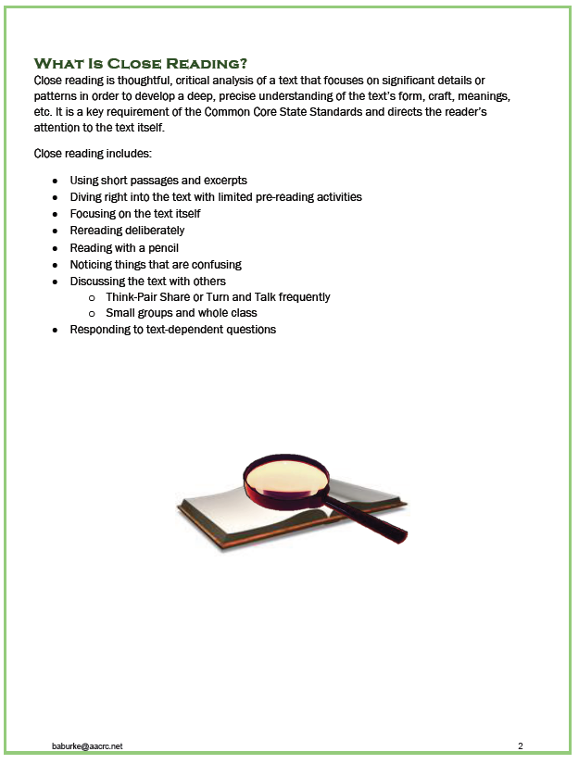

* **Use Kagan Structures such as: Timed Pair Share, Rally Robin, Pairs Compare, etc.**