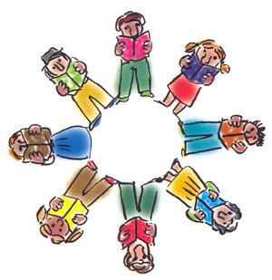
Strategies that Work
Literature Circles
Team Members:
______________________________________________________________________________________________________________________________________________________
Pages:__________
Illuminator

As you read and think about issues, current thinking and practice, your
role is to draw what you read. This might mean drawing a scene as a cartoonlike
sequence, or an important scene so readers can better understand the action. You can draw maps or organizational trees to show how one person, place, or event relates to the others. Use the notes area to explain how your drawing relates to the text.
Notes:

