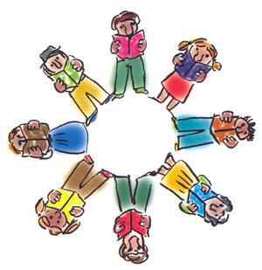ELA Literature Circles
Team Members:
______________________________________________________________________________________________________________________________________________________
Book Title:_____________________________
Pages:____________________
Questioner

As you read and think about issues, current thinking and practice write down a few questions that you had about this selection. What were you wondering about while you were reading? Did you have questions about what was being described? How will I use this information? Just notice what questions pop into your mind while you read and write them down.
______________________________________________________________________________________________________________________________________________________________________________________________________________________________________________________________________________________________________________________________________________________________________________________________________________________________________________________________________________________________________________________________________________________________________________________________________________________________________________________________________________________________________________________________________________________________________________________________________________

