Google Slides
Choose slides from the Waffle
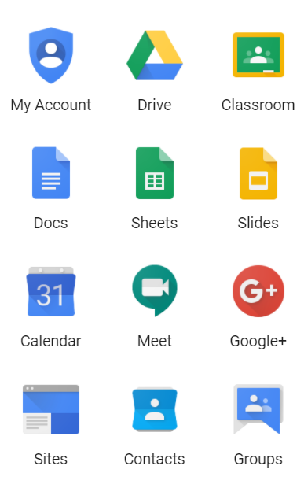

How to Create a Google Slide
- Click on Start a New Presentation.
- You can leave blank or select a theme from the right hand selection pane.
How to Add Text
- Click insert from the top tool bar and select text box.
How to Add a Video
- Click insert from the top tool bar and select video.
- Type the URL in the You Tube box or paste the URL. The video will appear. Sometimes you made to go directly to the URL or Google Drive for your video.
