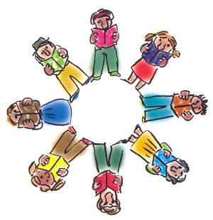ELA Literature Circles
Team Members:
______________________________________________________________________________________________________________________________________________________
Book Title:_____________________________
Pages:____________________
Passage Master

As you read and think about issues, current thinking and practice locate key sentences or paragraphs that the group should review. The idea is to help people notice the most important, interesting, puzzling or relevant sections of the text. You can read passages aloud yourself, ask someone else to read them, or have people read them silently and then discuss why the passage stands out.
______________________________________________________________________________________________________________________________________________________________________________________________________________________________________________________________________________________________________________________________________________________________________________________________________________________________________________________________________________________________________________________________________________________________________________________________________________________________________________________________________________________________________________________________________________________________________________________________________________

