Google Hangouts
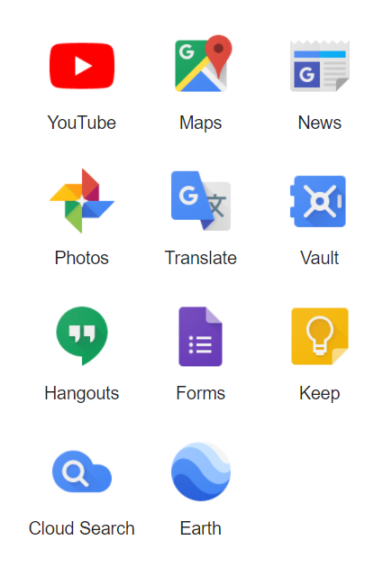
Click on Hangouts from the Waffle
How to Start a Google Hangout
- Type an email address in the new conversation box.

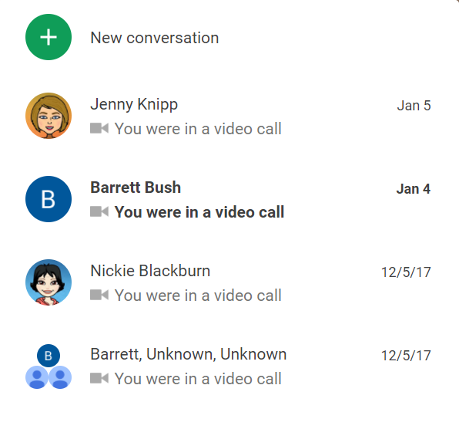
- Click video call.
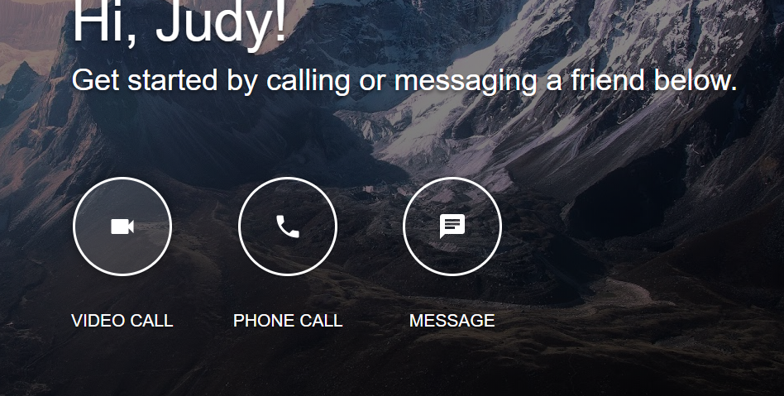

- To add a new participant to the video call click on invite or the people symbol.
